Physics Undergraduates Intern at University of Gdańsk, Poland with Student Exchange Program
Published on April 14, 2023
Department of Physics
Two third-year students from Physics programme, Xiamen University Malaysia, are enjoying their internship at University of Gdańsk, Poland, under the inaugural Research Internship Student Exchange Program.
This program was initiated by Department of Physics, Xiamen University Malaysia and Faculty of Mathematics, Physics and Informatics, University of Gdańsk, in January 2023, allowing students from both departments to do a research internship at the other university and enrich their global experience.
University of Gdańsk is world famous for its discoveries in quantum information and the home of International Center for Theory of Quantum Technologies. Currently, Prof. Tomasz Paterek from XMUM Department of Physics is collaborating with the Center and the Institute of Theoretical Physics and Astrophysics on quantum correlations, Bell inequalities, foundations of physics, and quantum optics.
The two students who are currently undergoing their research internship shared their experiences:
Ng Khai Shuen
I’m now working on general relativity minimally coupled to massless scalar fields. The goal of this project is to look for more classes of solutions in spacetimes where gravity sometimes repulses instead of attracts (i.e., has an opposite effect) - as of now, it was shown to be the case for one particular solution only.
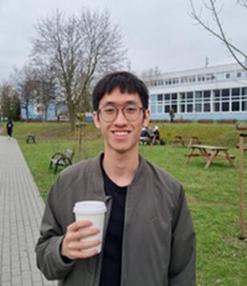

For me, this is a very good time to gain exposure; not just to different cultures and new people, but to see how people approach physics outside of my local setting, and to learn from them. One can argue that physics is still physics across different languages and cultures, but I think everyone has different sensibilities and “feels” when approaching math or physics.
These differences, which essentially constitute one’s way of thinking, influence the formation of one’s ideas; and seeing as much of that as we can is imperative, especially as a budding young scientist (or whatever you plan to do in the future). Broaden your horizons and learn from as many sources as you can!
Ong Ming Khai
I will be studying the relationship between solar activity and climate indicators, which takes historical records of sunspot numbers, climate data, and tree ring records into account to determine the degree of influence that variations in the Sun have on Earth's climate. Python programming will be used to help automate the process of primary component analysis of large amounts of data and apply statistical studies to the results.
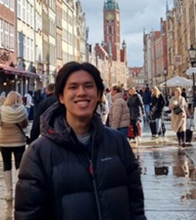
The internship program has allowed me to get a real feel of academic research, and I am very grateful to have the opportunity to conduct this research in a new environment. I’m definitely excited to be here, despite the cold temperatures!
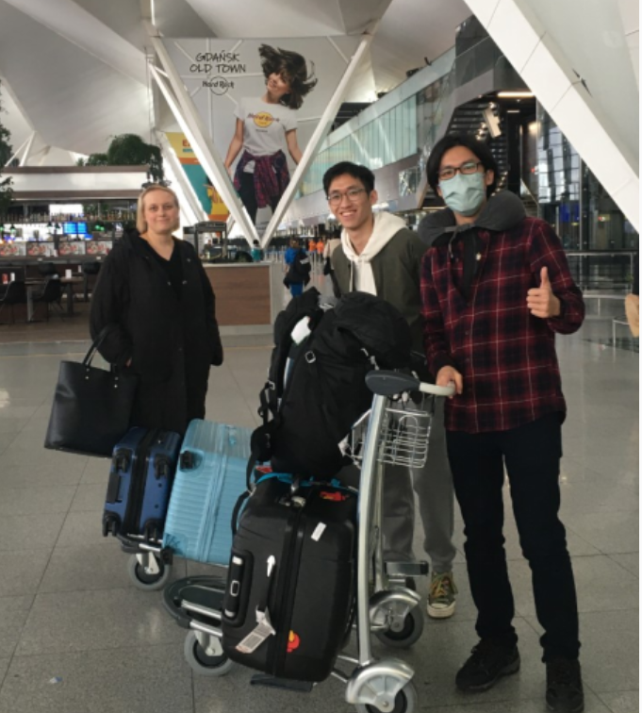

Khai Shuen and Ming Khai were greeted by Ms. Gosia on arrival at the Gdańsk airport
For more information about the Physics Research Internship Student Exchange Programme, please contact Prof. Tomasz Paterek at paterek.tomasz@xmu.edu.my
For more information on the BSc Physics (Hons.) programme, visit the physics webpage at department of physics page

